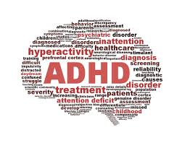
PARENTING IN THE 21ST CENTURY –
NOT THE WAY MOM AND DAD DID IT

UNDERSTANDING ADHD
IN YOUR KIDS

When:
- Thursday, September 29th, 2016
- Refreshments at 6:00pm
- Presentation from 6:30-8:30pm

Where: Port Moody Inlet Theatre, 100 Newport Drive, Port Moody

Speakers:
Dr. Lili Nasseri, MD - Physician Lead for CYMHSU in the Tri-Cities
Andrea Hansen –Parent with lived experience
Jeff Rasmussen – Youth with lived experience

~ A MUST ATTEND FOR ALL PARENTS

This event is FREE but space is limited, so register early!

Register at: https://www.eventbrite.ca/e/understanding-adhd-in-your-kids-tickets-27177605951

This FREE speaker series is put on by the Tri-Cities Child and Youth Mental Health Substance Use Collaborative (CYMHSU)– a partnership created by Fraser Northwest Division of Family Practice (nonprofit) and Doctors of BC.

